CS 305 Project One Template

Document Revision History

Version | Date | Author | Comments
1.0 | 5/31/2026 | Veronica Malewski

Client



Instructions
Submit this completed vulnerability assessment report. Replace the bracketed text with the relevant information. In this report, identify your security vulnerability findings and recommend the next steps to remedy the issues you have found.

- Respond to the five steps outlined below and include your findings.
- Respond using your own words. You may also include images or supporting materials. If you include them, make certain to insert them in the relevant locations in the document.
- Refer to the Project One Guidelines and Rubric for more detailed instructions about each section of the template.

Developer
Veronica Malewski

1. Interpreting Client Needs

For Artemis Financial, I would first look at the kind of information the company handles and how that information moves through the application. Since Artemis Financial works with savings, retirement, investments, and insurance planning, secure communication is important. Customers need to trust that their personal and financial information is protected when it moves between the client and the server. If that communication is not protected, an outside attacker could try to intercept it, change it, or use it in a way the customer never intended.

The scenario does not clearly say that Artemis Financial currently handles international transactions. Still, the company is trying to modernize its operations, so it should be thinking ahead. If Artemis Financial later works with customers outside the United States, the application may need to meet additional privacy or security requirements depending on where those customers are located. Because of that, it makes sense to build the application with stronger security in mind now instead of waiting until later. Government restrictions should also be considered because this application is tied to financial services. The scenario does not name one specific law, but financial applications are generally expected to protect customer information and use secure communication. If the application does not protect information properly, the company could lose customer trust and may also create legal or business risk.

The main outside threats I would look for are attacks against the web API, injection attacks, weak input validation, denial of service attacks, exposed error details, and vulnerable third-party dependencies. Since this is a Spring web application, users interact with the server through endpoints. That makes the endpoints important because they are the places where outside input reaches the application.

Modernization is also a big part. Artemis Financial uses open-source libraries and web application technology, which can make development faster and easier. The issue is that those libraries still must be maintained. If a dependency gets old, it can have known vulnerabilities even if the application’s own code still works. Because of that, modernization should include updating dependencies, running regular dependency checks, validating input, improving API security, and handling errors more safely.

2. Areas of Security

For this application, I would focus on input validation, API security, cryptography, client/server interaction, code error handling, code quality, and encapsulation. These areas fit the vulnerability assessment process because the application is a Spring web application, accepts outside input through endpoints, uses third-party dependencies, and may handle sensitive financial information.
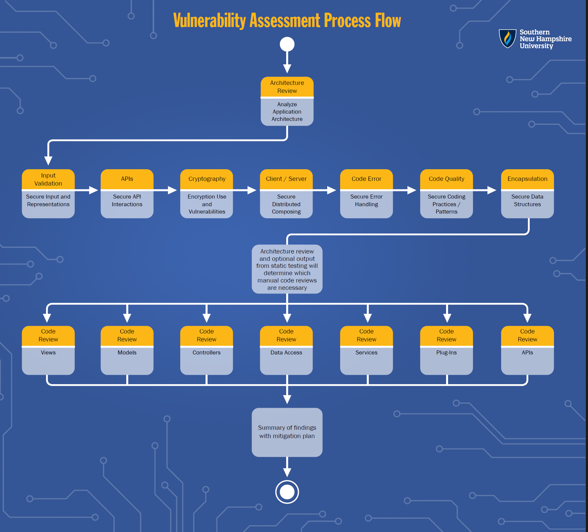
Figure 1. Vulnerability Assessment Process Flow Diagram, referred to and used in security review.

Input validation is one of the biggest concerns because the application takes in values from users through web endpoints. Anything coming from outside the program should be checked before the application uses it. Even if the input is only supposed to be simple text, it could still be entered in an unexpected way. Because of that, the application should not trust user input automatically.
API security also applies because Artemis Financial uses a RESTful web application. The endpoints are how users reach the server, so those endpoints need to be reviewed carefully. If an endpoint accepts unsafe input or gives back too much information, it could become an easy place for attackers to target.
Cryptography applies in this project because the application includes the Bouncy Castle dependency, “bcprov-jdk15on 1.46”. The dependency-check report showed that this older version has known vulnerabilities. Since Artemis Financial is connected to financial services, anything related to encryption or cryptography should be treated carefully.
Client/server interaction matters because the application sends and receives information between the user and the server. The server should be careful about what it accepts and what it sends back. Secure communication matters here because the application may be handling information that customers would expect to stay private.
Code error handling is also important because the program should not crash or reveal extra details when something goes wrong. A user should only see a simple error message. The more detailed technical information should stay in developer logs, not in a response that outside users can read.
Code quality applies because secure code should still behave safely when users enter something wrong. If the code is incomplete, outdated, or written loosely, security issues can be easier to miss. Since this application is connected to financial services, the code should be clear, consistent, and easier to maintain.
Encapsulation also applies because the application has classes that organize customer or account-related information. Those values should be protected with private fields and controlled methods. That helps prevent important information from being changed in unsafe or unexpected ways.

Altogether, these areas matter because the application accepts user input, runs as a web service, uses open-source dependencies, and may handle financial information. The goal is to make sure the application checks outside input before using it, protects communication, handles errors safely, keeps dependencies updated, and controls how data is accessed.

3. Manual Review

While manually reviewing the code, I noticed a few security concerns that should be fixed before the application is considered secure. The biggest issues were incomplete logic, weak input validation, outdated dependencies, and unsafe handling of database information.

One issue I found is in “DocData.java”. The database connection has the username and password written directly into the code: “DriverManager.getConnection("jdbc:mysql://localhost:3306/test","root","root");”.

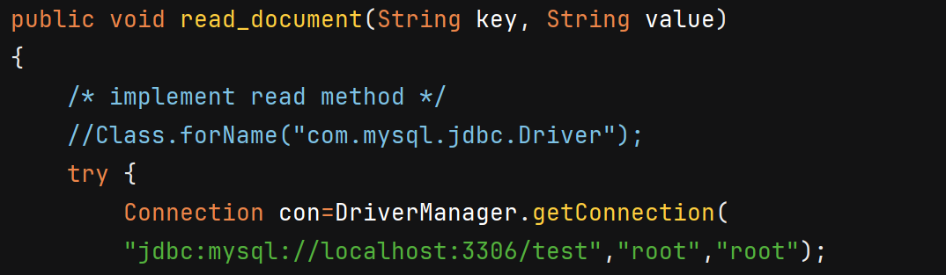
Figure 2. Hard-coded database credentials found in DocData.java.

As shown in Figure 2, this is risky because the database credentials are hard-coded. If the source code is shared, uploaded, or exposed, the database login information is exposed with it. Credentials should not be stored directly in source code.

Another issue in “DocData.java” is that the application uses the “root” database account. This gives the application more access than it should need. If the application were compromised, using “root” could make the damage worse because the attacker may get higher database privileges. A safer approach would be to use a dedicated database user with only the permissions required for the application.

I also found an error handling issue in “DocData.java”. The catch block uses: “e.printStackTrace();”. This can expose internal technical details if an error occurs. Stack traces can reveal class names, database issues, file paths, or other information about how the application works. That information could help an attacker understand the system. A safer approach would be to log the error on the server and return a simple controlled error message to the user.

Another issue is in “CRUDController.java”. The “/read” endpoint accepts a user-controlled value called “business_name”: “@RequestParam(value="business_name") String name”. The problem is that this value is not validated before the method continues. Even though the current method does not fully use the value yet, it appears intended to support reading documents or business data. If this value is later used in a database query, document lookup, or file search, it could create a security issue. The input should be validated before it is used.

The “/read” endpoint also creates a “DocData” object and returns “doc.toString()”: “return new CRUD(doc.toString());”. This does not actually return controlled business data. Instead, it returns the object’s default string representation unless “toString()” is overridden. This is a code quality issue because it does not appear to perform the intended read operation. In a real application, this could lead to unreliable behavior or accidental exposure of internal object details if the class later changes.

Another issue is in “DocData.java” with the “read_document(String key, String value)” method. This method accepts parameters, but the actual read method is not implemented. Since it is clearly intended to interact with a database, it should be designed carefully before being used. Any future database query should use prepared statements instead of building SQL with user input. This matters because directly using user-controlled values in SQL can create SQL injection risk.

I also noticed an input validation issue in “GreetingController.java”. The “/greeting” endpoint accepts a “name” value from the user: “@RequestParam(value = "name", defaultValue = "World") String name”. Then it places that value directly into the response with: “String.format(template, name)”. This still trusts outside input quickly. The application should check that the name is a reasonable length and only contains expected characters. If this response is displayed in a browser or reused by another system, unsafe or unexpected input could create problems.

The “application.properties” file also allows large file uploads. The file size limit is set to 200MB, and the request size limit is set to 215MB. If the application does not truly need uploads this large, this could increase denial of service risk. Attackers may try to send large files or repeated upload requests to use up server resources. The application should limit file size based on actual business need and validate uploaded content.

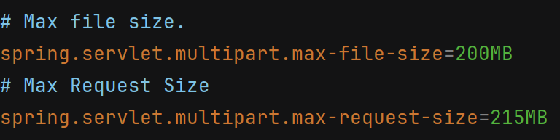
Figure 3. Large upload limits configured in application.properties.

Another issue is in the “customer.java” class. The “account_balance” field is not private:
“int account_balance;”. The “deposit(int a)” method also does not validate the amount:
“account_balance = account_balance + a;”.

Since this application is for a financial company, account-related values should be protected. A negative value could reduce the account balance instead of acting like a real deposit. The field should be private, and the method should only accept valid positive deposit amounts.

The “myDateTime.java” class also has incomplete validation. The fields “mySecond”, “myMinute”, and “myHour” are not private, and the “setMyDateTime(int seconds, int minutes, int hour)” method is empty. If this class is used later, invalid time values could be accepted. Seconds and minutes should be limited to valid ranges, and the method should actually set the values in a controlled way.

Overall, the manual review showed that the application needs stronger validation, safer database handling, better error handling, and better encapsulation. Some issues are already visible in the code, while others could become bigger problems if the incomplete methods are expanded without secure coding practices.

4. Static Testing
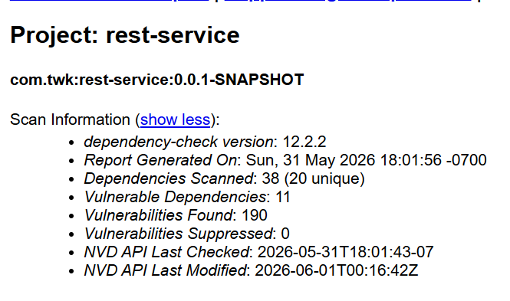

Figure 4. OWASP Dependency-Check scan summary for the rest-service project.

OWASP Dependency-Check was run on the Artemis Financial “rest-service” project to check for known vulnerabilities in the application’s third-party dependencies. The scan used Dependency-Check version “12.2.2”. The report showed that 38 dependencies were scanned, including 20 unique dependencies. It found 11 vulnerable dependencies and 190 total vulnerabilities, with no vulnerabilities suppressed.

One vulnerable dependency was “bcprov-jdk15on-1.46.jar”, which is part of the Bouncy Castle cryptography package. This dependency was marked high severity and had 4 CVEs. The report listed “CVE-2016-1000338”, “CVE-2020-15522”, “CVE-2023-33202”, and “CVE-2015-7940”. These issues relate to cryptographic verification, timing concerns, denial of service risk, and possible exposure of sensitive cryptographic information. Since this dependency is connected to cryptography, a better fix would be to update Bouncy Castle to a current supported version or remove it if the application does not actually need it.

Another vulnerable dependency was “hibernate-validator-6.0.18.Final.jar”. This dependency was marked medium severity and had 3 CVEs. The report listed “CVE-2025-35036”, “CVE-2023-1932”, and “CVE-2020-10693”. These issues involve validation behavior, Expression Language handling, HTML injection, and possible cross-site scripting risk. This matters because validators are supposed to help control input, but an outdated validator can become part of the security problem. The main fix would be to update Hibernate Validator to a patched version.

The report also identified “jackson-databind-2.10.2.jar” as vulnerable. This dependency was marked high severity and had 6 CVEs. One of the listed vulnerabilities was “CVE-2020-25649”, which relates to XML external entity behavior. Since Jackson is commonly used to process data in web applications, outdated versions can create risk when the application handles outside data. The best next step would be to update Jackson Databind to a secure supported version.

The logging dependencies also showed vulnerabilities. “log4j-api-2.12.1.jar” was marked medium severity with 3 CVEs, and “logback-core-1.2.3.jar” was marked high severity with 2 CVEs. Logging libraries are important because they help developers monitor and troubleshoot the application. However, if logging dependencies are outdated, they can still create risk depending on how they are used. These dependencies should be updated to patched versions.

The dependency “snakeyaml-1.25.jar” was marked critical severity with 8 CVEs. SnakeYAML is used for YAML parsing, so outdated versions can create risks such as unsafe parsing behavior or denial of service. The main fix would be to update SnakeYAML through the Spring Boot dependency chain or directly update it if needed.

The report also showed that “spring-boot-2.2.4.RELEASE.jar” was marked critical severity with 8 CVEs. This is important because Spring Boot is the foundation of the application. If the framework itself is outdated, the rest of the application can inherit that risk. This should be updated by moving the Spring Boot parent version to a supported version.

Two of the most important findings were “spring-core-5.2.3.RELEASE.jar” and “spring-web-5.2.3.RELEASE.jar”. “spring-core-5.2.3.RELEASE.jar” was marked critical with 17 CVEs, and “spring-web-5.2.3.RELEASE.jar” was marked critical with 18 CVEs. Both were also marked as having known exploited vulnerabilities. Since these dependencies are central to how the Spring application works, they should be treated as high priority updates.

The embedded Tomcat dependencies were also major findings. “tomcat-embed-core-9.0.30.jar” was marked critical with 60 CVEs, and “tomcat-embed-websocket-9.0.30.jar” was marked critical with 61 CVEs. Both were marked as having known exploited vulnerabilities. Since Tomcat supports the server runtime, these findings matter because they could affect the security of the running web application. This should be treated as a high priority and fixed by updating the embedded Tomcat version through a Spring Boot update or direct dependency management.

The report documented these issues with CVE numbers, package names, CPE identifiers, Maven package identifiers, and outside references such as vendor advisories, patch notes, MITRE references, Red Hat references, and third-party advisories. Overall, the static test makes it pretty clear that dependency management is one of the biggest issues in this project. Even if the application code still runs, outdated third-party libraries can still create major security risks. The main fix would be to update the Spring Boot parent version and other outdated dependencies, then rerun Dependency-Check to make sure the number of vulnerabilities goes down.

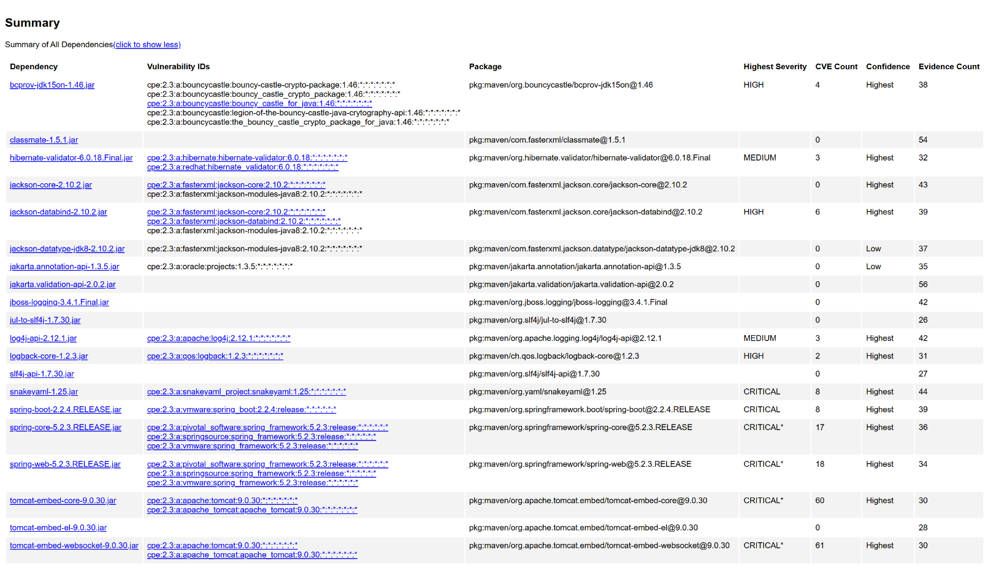

Figure 5. Summary of vulnerable dependencies identified by OWASP Dependency-Check.

5. Mitigation Plan
Based on both the manual review and static testing results, the biggest priorities are updating dependencies, fixing database handling, validating input, and improving error handling. The dependency-check report found several outdated libraries, including “spring-boot-2.2.4.RELEASE.jar”, “spring-core-5.2.3.RELEASE.jar”, “spring-web-5.2.3.RELEASE.jar”, “tomcat-embed-core-9.0.30.jar”, “tomcat-embed-websocket-9.0.30.jar”, “snakeyaml-1.25.jar”, “jackson-databind-2.10.2.jar”, and “bcprov-jdk15on-1.46.jar”. Since many of these dependencies are part of the Spring Boot dependency chain, the main fix would be to update the Spring Boot parent version first. After that, OWASP Dependency-Check should be run again to confirm that the number of vulnerable dependencies and CVEs has gone down.

The Bouncy Castle dependency should also be updated or removed. The project currently uses “bcprov-jdk15on-1.46.jar”, which was marked as vulnerable in the dependency-check report. Since this dependency is related to cryptography, it should be treated as a higher priority. If the application does not actually need Bouncy Castle, then the safest option would be to remove it from “pom.xml”. If it is needed, it should be updated to a current supported version.

The database connection in “DocData.java” should be changed because the code currently includes: “DriverManager.getConnection("jdbc:mysql://localhost:3306/test","root","root");”. The username and password should not be written directly into the source code. A safer approach would be to store the database credentials in environment variables, secure configuration, or a secrets manager. This would help prevent the credentials from being exposed if the code is shared or uploaded.

The application should also stop using the “root” database account. Using “root” gives the application more access than it should need. A better fix would be to create a separate database user just for this application and only give it the permissions required for its normal work. This follows the principle of least privilege and would reduce the damage if the application were ever compromised.

For database access, the “read_document(String key, String value)” method should be completed carefully. If the method is later used to search or read from the database, it should use prepared statements instead of building SQL directly from user input. This matters because user-controlled values should not be allowed to change the structure of a database query. Prepared statements would help reduce the risk of SQL injection.

The “/read” endpoint in “CRUDController.java” should validate the “business_name” value before using it. Right now, the endpoint accepts outside input through “@RequestParam(value="business_name") String name”. The application should check that the value is in an acceptable format and is a reasonable length. If this value is used to look up business or document data, the application should also verify that the user is allowed to access that information.

The “/greeting” endpoint in “GreetingController.java” should also validate the “name” value before using it in “String.format(template, name)”. The program should only allow reasonable name input, such as letters, spaces, and a safe length. If the response is ever displayed in a browser or used by another system, the output should also be encoded safely.

The error handling in “DocData.java” should be improved. The code currently uses “e.printStackTrace();”, which can expose internal details if something goes wrong. The application should replace this with proper server-side logging. Users should only receive a simple error message, while detailed technical information should stay in developer logs.

The upload settings in “application.properties” should be reviewed. The current file size limit is set to “200MB”, and the request size limit is set to “215MB”. If the application does not actually need files that large, these limits should be reduced. The application should also validate file types, scan uploaded files when appropriate, and limit repeated upload attempts to reduce denial of service risk.

The “customer.java” class should be updated to protect account data better. The “account_balance” field should be private instead of directly accessible. The “deposit(int a)” method should also validate the deposit amount before changing the balance. A negative deposit should not be accepted because that could reduce the balance instead of acting like a real deposit.

The “myDateTime.java” class should also be finished and validated. The fields “mySecond”, “myMinute”, and “myHour” should be private, and “setMyDateTime(int seconds, int minutes, int hour)” should actually check and set the values. Seconds and minutes should stay within 0 to 59, and the hour value should stay within an acceptable range. Even smaller utility classes should avoid accepting invalid values.

Overall, the mitigation plan is to update vulnerable dependencies, remove hard-coded credentials, use least privilege for database access, validate user input, improve error handling, reduce upload risk, and strengthen encapsulation. After these changes are made, the team should rerun OWASP Dependency-Check and complete another manual review. This would help confirm that the fixes reduced the security risks instead of only changing the code on the surface.

